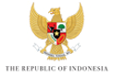

KICK-OFF MEETING of the 10TH WORLD WATER FORUM
BREAKOUT SESSION – DISASTER RISK REDUCTION AND MANAGEMENT

TABLE SHEET

Using keywords, please name the five or six most relevant topics that could be addressed by the Theme “DISASTER RISK REDUCTION AND MANAGEMENT”.

1.

2.

3.

4.

5.

6.

