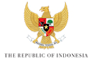

KICK-OFF MEETING of the 10TH WORLD WATER FORUM
BREAKOUT SESSION – WATER FOR HUMANS AND NATURE

RAPPORTEUR SHEET

What are the five most important issues that should be addressed by the Theme “WATER FOR HUMANS AND NATURE”?

1.

2.

3.

4.

5.

6.

